Anthony Makana Paris
1.096
Prof. Eltahir
3.8.04

Sedimentology of the Nile

Introduction

The process of sedimentation happens in the following stages: 1) Erosion, 2) Entrainment (drawing of particles into a fluid), 3) Transportation, 4) Deposition, and 4) Compaction.
These processes are highly complex. The detachment of particles in the erosion process occurs through the kinetic energy of raindrop impact, or by flowing water. Once a particle has been detached, it must be entrained before it can be transported away. Both entrainment and transport depends heavily upon the weight, shape, size, and the forces exerted on the particle by the flow. Deposition occurs when the forces are diminished enough seeing a reduction or cessation of transport. For the scope of the Merowe sustainability assessment project, we will be primarily concerned with erosion, transportation, and deposition.

Erosion: Sources of Nile Sediment

Most of the sedimentation from the Nile flows from the Ethiopian highlands through the Blue Nile and the Atbara. The White Nile and its tributaries lose most of its sediment load by spilling and deposition over flood plains, lakes, and marshlands. Nearly all of the sediment (~90%) comes from the Blue Nile during the flood season (July-October). El Moushid estimates the sediment load of the Blue Nile at el Diem to be 140 million tones per year. From this estimate, the sediment concentration peaks at ~6000 ppm in August. In addition, there is an estimate of a mean sediment load of 160 million tones for the main Nile as measured at Gaarfra. This comes from a UNESCO (United Nations Educational, Scientific, and Cultural Organization) regression analysis of all available field data from before 1964. They also found that the sediment load has a range of 50-300 million tones per year. This author has not been able to find any sediment load information that is specific to the Merowe Dam site or any other sights that are in its vicinity.

Transportation

Sediment is carried and transported in two forms, 1) Suspension and 2) Bed-load. Suspension is where the particulates travel while suspended in the water column, while bed-load is the movement of sediment along the river bed. The Blue Nile transports both pebbles and boulders from its headwaters down to the Roseires reservoir. As the slope of the Blue Nile diminishes, so does the mean size of the transported sediment. This is extremely characteristic of alluvial rivers. There are two possible causes for this: 1) there is a general reduction in size due to the wear and tear on the grains caused by the friction between the particles as they are rolling down the river channel and 2) that the steeper slopes are indicative of higher flow velocities and larger particles can be transported here while as the slope decreases, so does the flow velocity, and the transport capacity of the fluid. Ultimately, the coarser grained sediment is mostly left behind. Thus, having a mixture of little gravel-sized material and finer grain sediment reaching the main river.

Currently there is no reliable means of measuring the bed-load in the Nile. Hurst et al. have assigned a bed-load of 25%, which is the amount that has been found for other rivers similar to the Nile. However, they also discuss that the bed-load of the Nile could not be that much do to a lack of evidence of an increasing rise of the river bed upstream of the Aswan Low Dam. Hence, it is this author's opinion that we can treat bed-load as negligible. We also find that the suspended sediment load distribution is Clay (< 0.002 mm) 30%: Silt (0.002-0.02 mm) 40%: Fine Sand (0.02-0.2 mm) 30%.

Deposition: Reservoir

Deposition is the counterpart of erosion. When river flow enters a reservoir, its velocity and transport capacity is reduced and its sediment load is eventually deposited. The amount and rate of deposit is determined mainly by detention storage time, the shape of the reservoir, and the operating procedures of the reservoir. The depositional pattern usually starts with the coarser material depositing towards the reservoir headwaters. The aggradation continues more and more until a delta is formed. See figure 1.

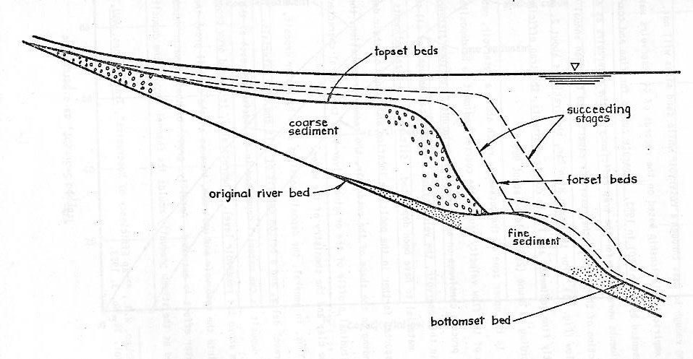
Figure 1

Aswan Figures

This author believes that the sediment rates at the Aswan High Dam can be used to represent the sediment loads at the Merowe dam site. Hurst et al. estimates the mean annual sediment load to be approximately 134 million tons at Aswan. The following table shows the distribution of the load over the course of the year:

Month | Sediment Load (million tons)
January | 0.29
February | 0.15
March | 0.11
April | 0.13
May | 0.08
June | 0.09
July | 1.81
August | 56.22
September | 56.64
October | 15.54
November | 2.15
December | 0.53

Non-Flood Season Flow Rates

Q = 43 x 10⁶ m³/day
Q_{WHITE} = 37.5 x 10⁶ m³/day
Q_{BLUE} = 7.5 x 10⁶ m³/day
Q_{Peak-August} = 730 x 10⁶ m³/day

Flood Season Flow Rates

Q_{WHITE} = 75 x 10⁶ m³/day
Q_{BLUE} = 495 x 10⁶ m³/day
Q_{ATBARA} = 160 x 10⁶ m³/day

Discussion

There is a range of total Nile Sediment load from 134-160 million tones per year. This discrepancy could be caused by the estimated bed-load values used to calculate the total annual sediment load. The UNESCO team may have used a bed-load estimate of 26 million tons per year. Also, the El Moushid indicates that the range of 134-160 is a reasonable estimate for total sediment load of the Nile at Aswan.

End Notes

Vito A. Vanoni. (1975) Sedimentation Engineering. American Society of Civil Engineers. pg. 1
V. D. Novozhenin and A. M. Lapshin. (2000) Exploitation of Water and Hydropower Resources of the Nile. Hydrotechnical Construction, Vol. 24, Nos. 8-9. pg. 460.
El Moushid, B. E. F., El Awad, O. M. A. & Ahmed, S. E. (1997) Environmental effect of the Blue Nile sediment on reservoirs and irrigation canals. In: 5th Nile 2002 Conf. (Addis Abada).
M. Gamal Mostafa. Sediment Processes in the Nile River. (1981) Water Master Plan. UNDP Technical Report 12.
Vanoni pg. 12
Hurst, Black and Simaika. (1978) The Nile Basin, Vol. XI. Egyptian Government Press, Ciaro.
Vanoni pg. 12

