Fill-in the blank
proposal to conceive, design, prototype, and evaluate a ____name/describe/define/identify your solution____ device
to keep coffee hot for two hours

__fill in your name here__

Summary: In order to keep coffee warm during a 2 hour class so that the instructor will not become grumpy, I propose to conceive, design, prototype, and evaluate a ___name/describe/define/identify your solution____ device. Conception and design is accomplished via a collaborative, fractal, recursive process of brainstorming and idea selection as documented in my notebook. The resulting design concept is ___characterize your design concept___. The design must__list your FRs__. These requirements are addressed by, __DPs__. __Analysis method(s)__ is (are) used to predict the performance of __device__. __Risks__ are taken into account and addressed by __coutermeasures__. The predicted performance of the proposed __device__ is __how well you think your device will work__. When implemented, the __device__ will make the world a better place by contributing to the happiness of Dave. If wildly successful, the __device__ could contribute to the happiness of millions of hot beverage consumers.

Introduction (problem definition)
A ___name/describe/define/identify your solution____ device that would keep a cup of coffee hot for two hours is of significant importance to Dave as well as the larger customer base of drinkers of coffee and other hot beverages. It is commonly observed that hot coffee, once served in a coffee cup, cools. Once cooled, coffee drinkers such as Dave are saddened, and the world would be a better place if they were not sad. To increase the net happiness in the world, this ES.033 project is to conceive, design, prototype, and evaluate a ___name/describe/define/__ device that will keep a cup of coffee hot for two hours. In addition to the requirement that the coffee remain hot, the product must satisfy three subsidiary requirements:
- The product must not expose the coffee drinker to undo hazard
- The product must be ergonomic and aesthetically pleasing
- The product must have a small ecological footprint, both in terms of the materials used to construct the product and the labor required to produce the product.
These requirements are weighted with the ultimate requirement that the coffee remain hot according to the rubric in Table 1. For environmental and economic reasons, the ___name/describe/define/identify your solution____ device shall be constructed of cardboard. If the design is successful, Dave will be happy, and the ___name/describe/define/identify your solution____ device can be marketed to the billions of consumers of hot beverages.

Table 1 “cost” of subsidiary requirements
requirement | cost incurred
Safe | The product must pass the tilt test, the pour test, and the roving eye test of due diligence. Any product that does not pass these tests is disqualified.
Ergonomics  & Aesthetics | A panel of experts will judge your prototype and place it in one of three categories: top quartile, middle quartiles, and bottom quartile.  - Products in the top quartile will have 10 minutes deducted from the time at which the temperature is measured.  - Products in the bottom quartile will have 10 minutes added to the time at which the temperature measured.
Eco-friendly | - If the mass of the product is less than the mass of the coffee, 10 minutes deducted from the time at which the temperature is measured.  - If the mass of the product is more than twice the mass of the coffee, 10 minutes will be added to the time at which the temperature is measured.  - If the product can be assembled in fewer than 15 minutes, 10 minutes will be deducted from the time at which the temperature is measured.  - If the product requires more than 15 minutes to assemble, 10 minutes will be added to the time at which the temperature is measured.

Background (model—how you think about keeping coffee hot)
Each of the functional requirements of the ___name/describe/define/identify your solution____ device needs to be investigated to guide the device design.

Thermal model
__How you model the temperature and heat transfer of a cooling cup of coffee._Best to define hot here. And cite sources. And include what you’ve found during in-class exploration and other preliminary experiments._

Safety analysis
__How do you “think about” (model) safety? What is your benchmark for “safe”?_ _

Aesthetics and ergonomics
__How do you “think about” (model) aesthetics and ergonomics? What is your benchmark for aesthetics and ergonomics?__

Materials and labor costs
__How have estimated materials and labor costs? Express these costs relative to the FRs, weight of the device and the amount of time it takes to construct.__

Methods (your plan)

Design overview
__What is your design? Describe it, big picture first—details following. Include at least one figure. Reference the figure(s) in the text. Explain how you chose this particular design and connect the design to functional requirements. Reference the selection and FRDPARRC tables.__

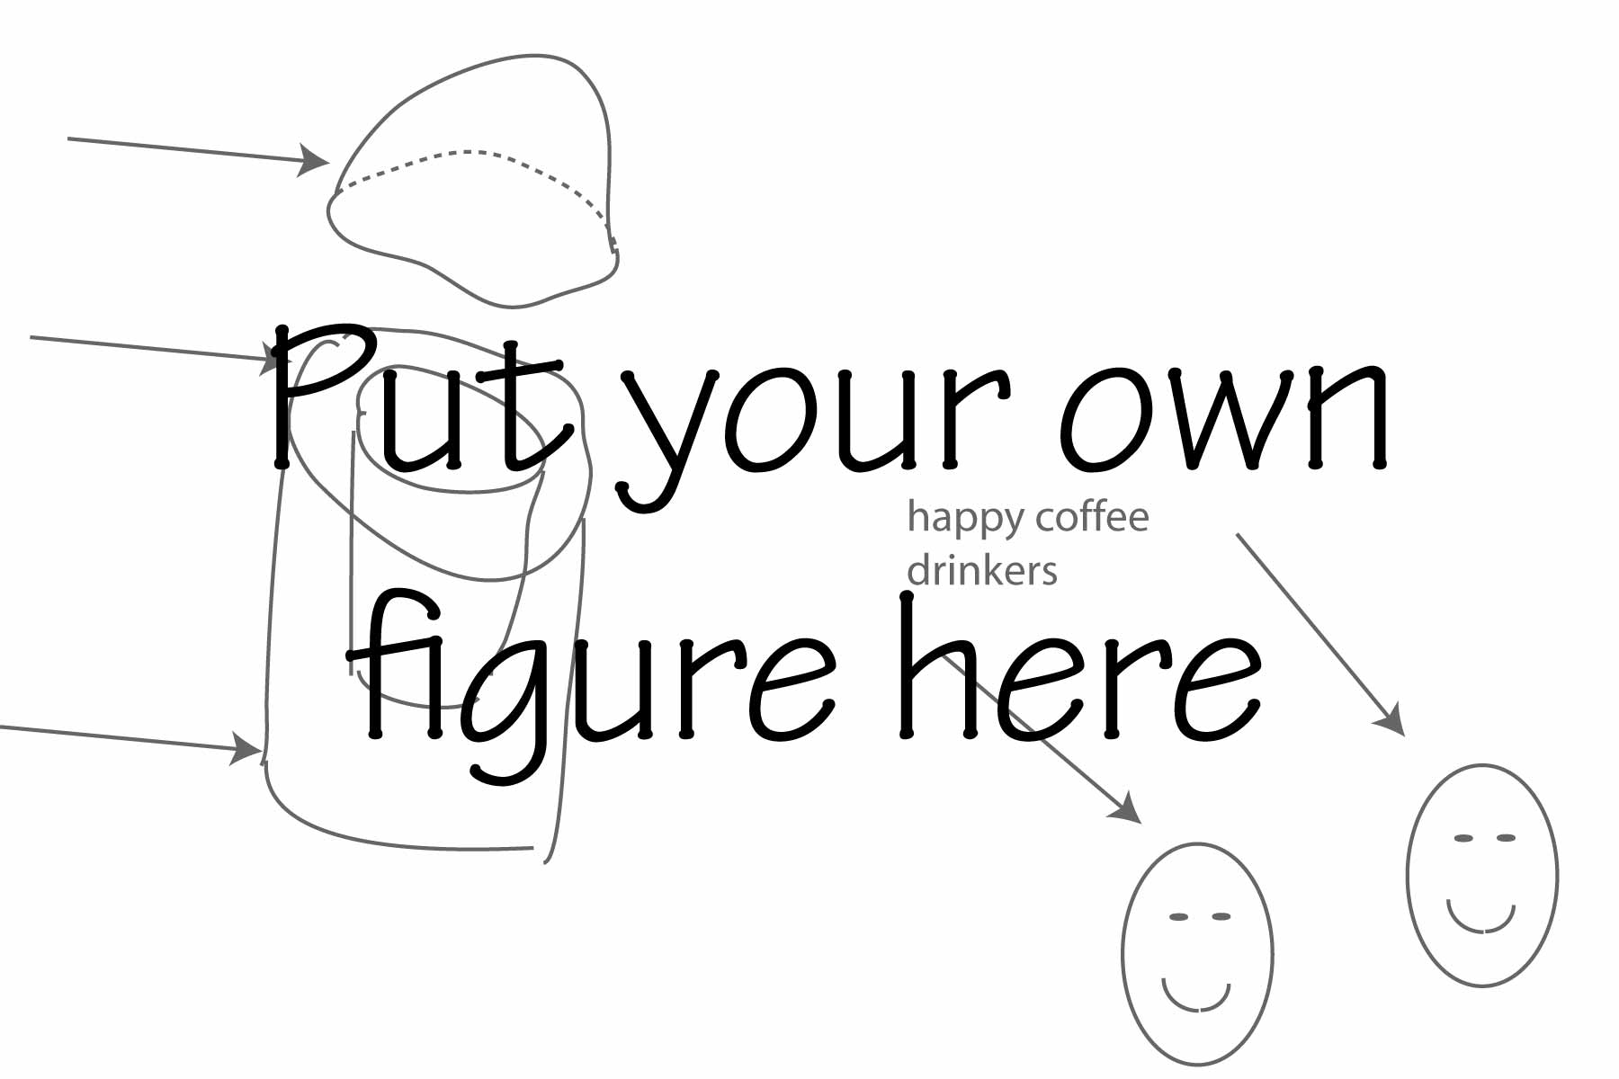
Fig 1 Overview of the _name_ design. Of particular importance are ___outline the important things__

Table 2 Design space selection criteria
 | technical slam dunk (or challenge) | personal interest | time commitment | sure to produce best result (highest coffee temperature) | sure to impress parental units, significant others, and potential employers | total
space 1 | +|x|- | +|x|- | +|x|- | +|x|- | +|x|- | #
space 2 | +|x|- | +|x|- | +|x|- | +|x|- | +|x|- | #
space 3 | +|x|- | +|x|- | +|x|- | +|x|- | +|x|- | #
baseline | +|x|- | +|x|- | +|x|- | +|x|- | +|x|- | #

Table 3 Design FRDPARRC (fill this in)
Functional Requirements | Design Parameters | Analysis | Research | Risks | Countermeasures
keeps coffee hot
safe
ergonomic and aesthetic
economical

Include text detail and perhaps figures for each functional requirement.

Device recipe

Provide a brief recipe (procedure, step in temporal order) for constructing your device. this cold appear in an appendix if you prefer.

Device testing

The ability of the name it device to keep coffee hot will be evaluated by measuring the temperature of a cup of coffee two hours after the coffee container ¾ full of freshly brewed coffee (or hot water) has been placed in the device. Aesthetics, ergonomics, and economics will be factored in as noted in Table 1. The tilt test is executed by tilting the surface to the angle at which the coffee would pour from the coffee container. The tilting should be gentle and occur over a period of 3 to 10 seconds. The pour test requires that the coffee can be poured from the name it device into another coffee cup without spilling coffee. The roving eye of safety test is intentionally left vague.

Other Stuff

Qualifications of primary investigator
__every so briefly note that you are a 1st year student at MIT and that your “design experience” is XXX (as per the discussion on the way to Carberry’s)__

References (according to IEEE style guide)

Deliverables and project schedule
Table 3 Project 1 Workflow schedule (pillage heavily from project I overview; adjust to actual schedule)
activity | deliverables | delivery dates
.
.
.

